1. **Spring Rest HandsOn**

**Hands on 1**

**Create a Spring Web Project using Maven**

* **Spring Initializr**

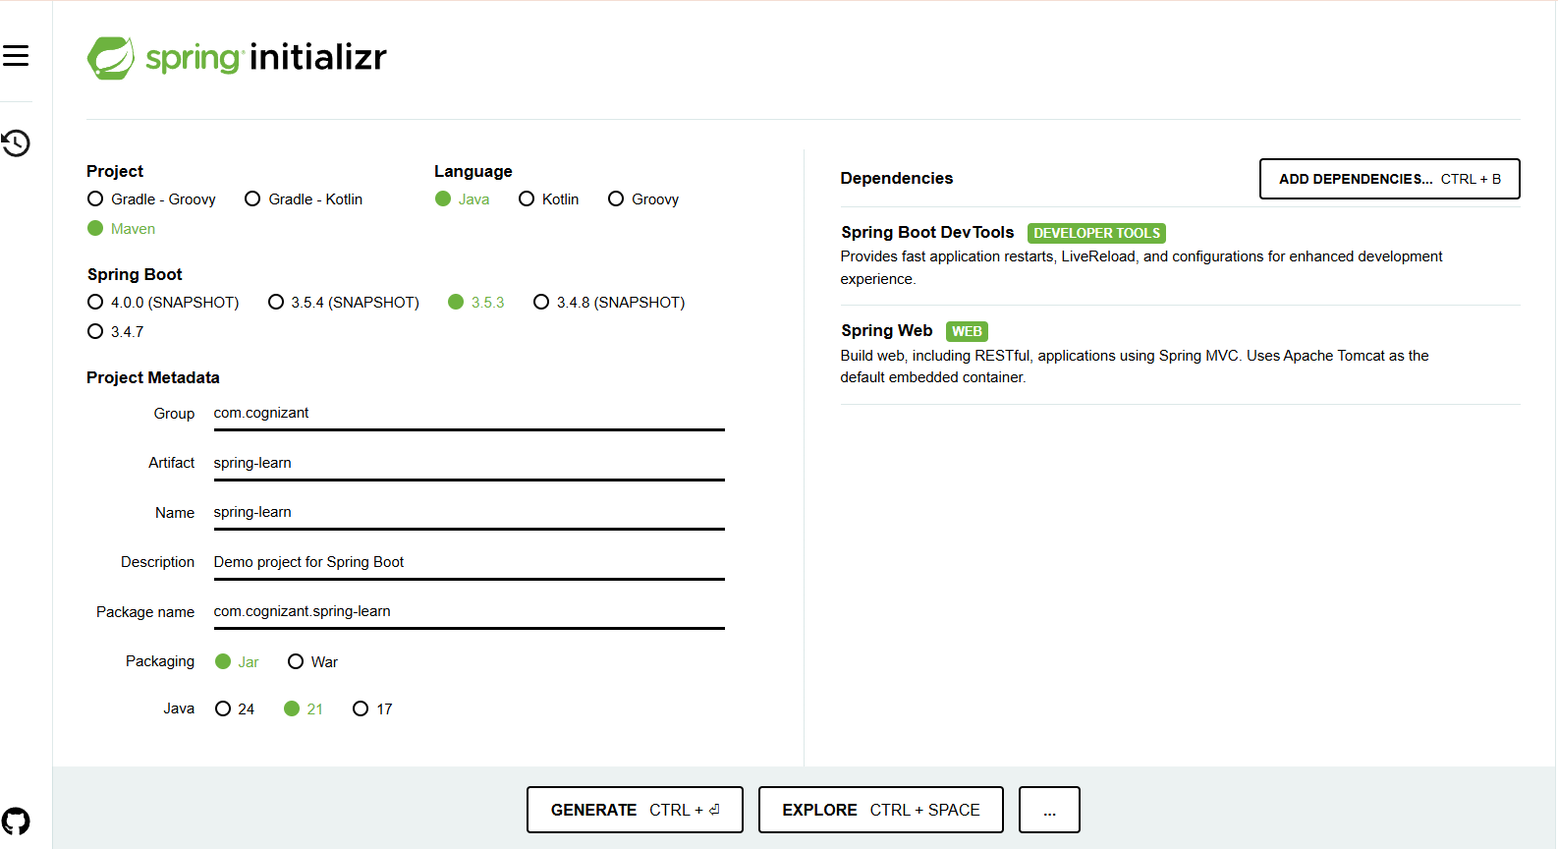

* **pom.xml**

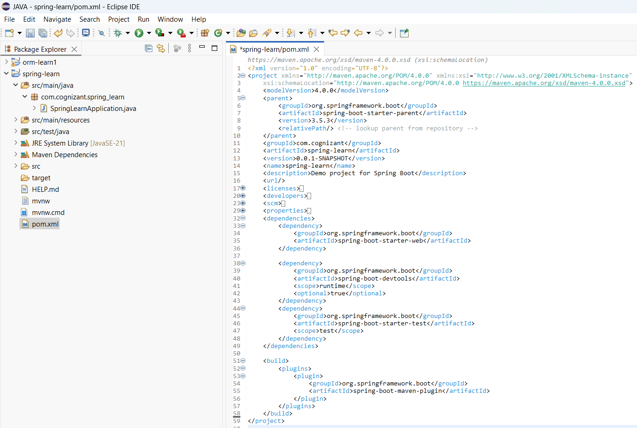

* **com.cognizant.spring_learn – SpringLearnApplication.java**

* **Console Output**

* **Logging**

* **Spring Boot Application Started**

**Hands on 4**

**Spring Core – Load Country from Spring Configuration XML**

* **pom.xml**



* **com.cognizant.springlearn – Country.java**

* **application.properties**

* **country.xml**

* **com.cognizant.springlearn – SpringLearnApplication.java**

* **Console Output**

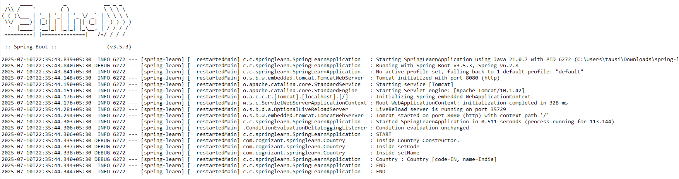

* **Logs**

